

Application Packet for The Cottages

Attached is the application for admission to The Cottages at Hopetree Family Services. We are licensed as a *Therapeutic Group Home* by the Department of Behavioral Health and Developmental Services and are CARF Accredited.

*Exclusionary criteria for this program includes:*

* *Convictions of sexual offenses, without completion of a Sex Offender Program*
* *History of intentionally starting fires with the intent to cause harm or significant property damage*
* *Chemically dependent and in need of inpatient treatment*
* *Actively psychotic, suicidal, or homicidal*
* *Convicted of violent crimes that would pose a risk to peers, self, or staff*
* *History of multiple violent actions that have not been moderated*

In addition to the attached documents, please provide the following when applicable:

* Recent School records including academic record, discipline reports, IEP, and immunizations.
* Recent Physical Exam report
* Psychological and/or Psychiatric Evaluations
* Court Reports
* Discharge Summaries, or last progress reports from previous placement (s)
* Intake Documents for other services (mentoring, IIH, TDT, etc.)
* Social History
* Custody Order (if in custody of DSS)
* IACCT assessment (if available)

**The following will be used to determine admission eligibility and whether this program and services can meet your child’s needs:**

* **Criteria for admission**
* **Information contained in the application**
* **Supporting documentation**

If you have any questions or need assistance, please do not hesitate to call. You can fax this application with supporting documents to 540-387-5082 to the attention of “Admissions” or email to [CottageAdmissions@hopetreefs.org](mailto:CottageAdmissions@hopetreefs.org).

Thank you for considering us to provide care for your child.





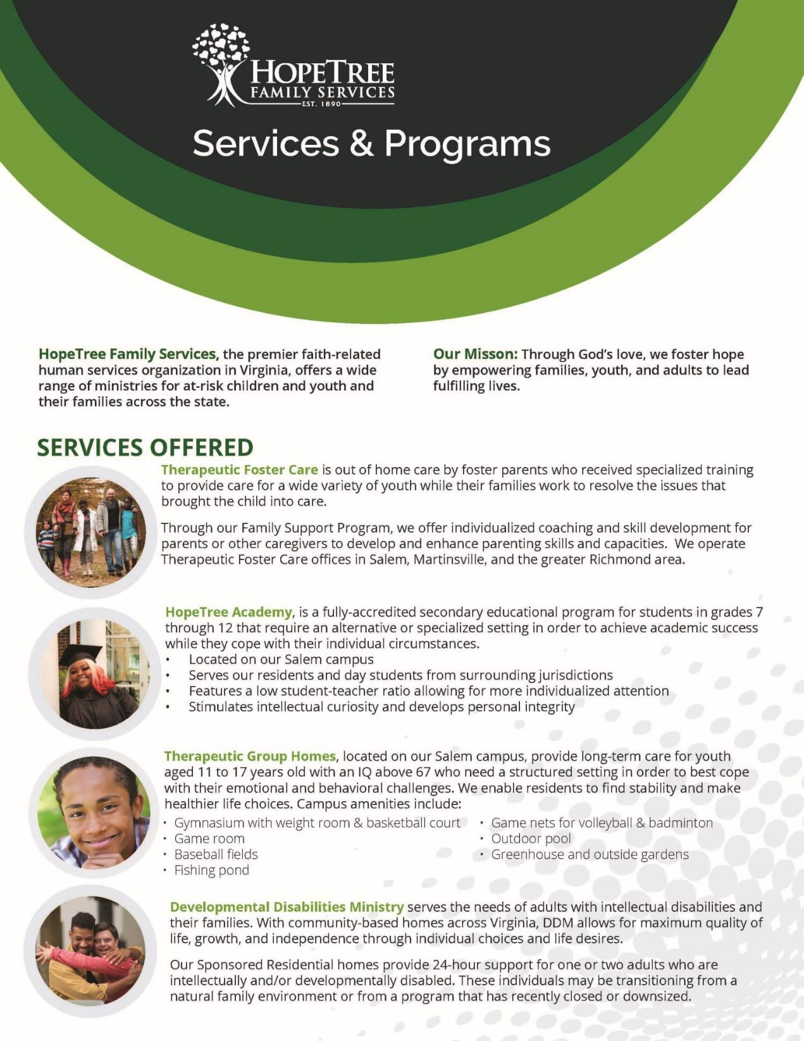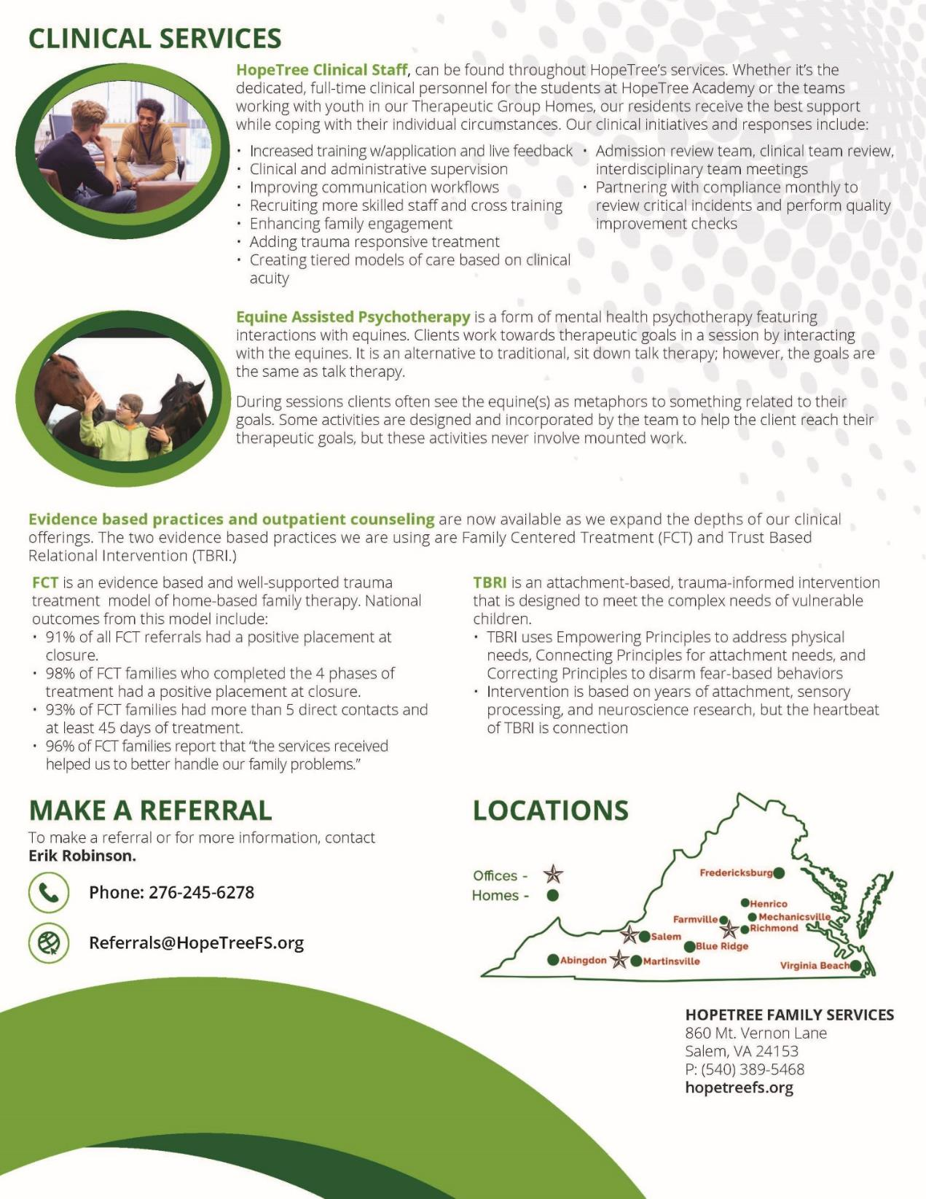



**Application for Admission to The Cottages at HopeTree**

**Demographics:**

|  |  |  |  |  |
| --- | --- | --- | --- | --- |
| **Date:**       **Date Placement Needed:** | | | | |
| **Child’s Full Name:** | | | | **Date of Birth:** |
| **Race:** | **Sex:** | | **Place of Birth:** | |
| **Child’s Religious Preference:** | | | | |
| **Child’s Current Physical Address:** | | | | |
| **Legal Guardian:** | | | | |
| **Legal Guardian Address:** | | | | |
| **Legal Guardian Phone:** | | **Legal Guardian Email:** | | |

**Emergency Contacts:**

**Name Relationship Phone #**

|  |  |  |
| --- | --- | --- |
|  |  |  |
|  |  |  |
|  |  |  |

**Provide brief description of current situation and why placement is needed now:**

|  |
| --- |
|  |

**Previous Placements:**

|  |  |
| --- | --- |
| 1. **Location:** | **Dates:** |
| **Reason Placement Ended:** | |
| 1. **Location:** | **Dates:** |
| **Reason Placement Ended:** | |
| 1. **Location:** | **Dates:** |
| **Reason Placement Ended:** | |

**Specify behaviors or issues that need to be addressed during your child’s placement:**

|  |
| --- |
|  |

**Specify behaviors or issue that need to be addressed during your child’s placement:**

|  |
| --- |
|  |

**What are your child’s behavior support needs? (behavioral triggers, anger/anxiety options):**

|  |
| --- |
|  |

**What past strategies/interventions have been successful?**

|  |
| --- |
|  |

**Has your child been referred to FAPT?**  **Yes**  **No**

|  |
| --- |
|  |

**If yes, what were the recommendations of FAPT?**

|  |
| --- |
|  |

**Medical History, Counseling/Prior Services of Child**

**A. List and date any past or current serious illnesses, injuries, hospitalizations:**

|  |
| --- |
|  |

**B. List and date any past or current drug or alcohol use/abuse:**

|  |
| --- |
|  |

**C. Allergies (drug, food):**

|  |
| --- |
|  |

**D. Date of last complete physical:**

|  |
| --- |
|  |

**Physician’s name, address and phone number:**

|  |
| --- |
|  |

**E. Last dental exam or checkup:**

|  |
| --- |
|  |

**Dentist’s name address and phone number:**

|  |
| --- |
|  |

**F. Last eye exam:**

|  |
| --- |
|  |

**Optometrist’s name, address and phone number:**

|  |
| --- |
|  |

**G. Immunizations needed?  Yes  No**

|  |
| --- |
| **If yes, what type:** |

**H. What are the child’s current physical needs? (any physically handicapping conditions)?**

|  |
| --- |
|  |

1. **What are the child’s current physical health needs?**

|  |
| --- |
|  |

**Current medications: (attach a list of meds if exceeds the spaces provided)**

**Medication** **Dosages Prescribed By:**

|  |  |  |
| --- | --- | --- |
|  |  |  |
|  |  |  |
|  |  |  |
|  |  |  |
|  |  |  |
|  |  |  |

**Has the child had a psychological, psychiatric or neurological exam?**  **Yes  No**

**If yes, please provide name of doctor(s) and dates of exams:**

|  |
| --- |
|  |

**What are your child’s current mental health, emotional and psychological needs?**

|  |
| --- |
|  |

**Does your child have a recent or past mental health diagnosis?  Yes  No**

**If yes, please provide diagnosis and the name of person who provided the diagnosis:**

|  |
| --- |
|  |

**Has your child received therapy in the past?  Yes  No**

|  |  |
| --- | --- |
| **Dates of Therapy:** | |
| **Reason for Therapy:** | |
| **Most recent Therapist:** | **Phone:** |
| **Outcome of Therapy:** | |

**Would the family participate in counseling provided at HopeTree?  Yes  No**

**If not, why?**

|  |
| --- |
|  |

**What are your child’s current educational needs?**

|  |  |  |
| --- | --- | --- |
|  | | |
| **Current or last school enrollment:** | | |
| **Grade Level:** | **Special Education:**  **Yes  No** | **What Classification?** |
| **List any school Issues or concerns?** | | |

**Are there any current or past legal charges/convictions?  Yes  No**

**If yes, please explain:**

|  |
| --- |
|  |

**Is child currently on probation?**  **Yes  No**

**If yes, Why?**

|  |  |
| --- | --- |
|  | |
| **Probation Officer:** | **Phone:** |

**Does your child have any protection needs? (to protect self/others)  Yes  No**

**If yes, please explain:**

|  |
| --- |
|  |

**Does your child have the following risks:**

**Suicide Risk** **Yes**  **No Homicidal Risk**  **Yes**  **No**

**Violence Risk**  **Yes**  **No AWOL Risk**  **Yes**  **No**

**If yes, please explain:**

|  |
| --- |
|  |

**Restrictions on your child’s visitor and/or phone lists:**

|  |
| --- |
|  |

**Would the admission of your child pose any significant risk to the child, other residents, or staff?  Yes  No**

**If yes, please explain:**

|  |
| --- |
|  |

**Describe child’s home environment, community and your involvement:**

|  |
| --- |
|  |

**Family History:**  **Biological Parent  Adoptive Parent**  **Step-Parent**

|  |  |  |
| --- | --- | --- |
| **Mother:** | **Marital Status:** | |
| **Address:** | | **Phone:** |
| **Occupation:** | | |

**Any past or current serious illnesses or chronic medical conditions:**

|  |
| --- |
|  |

**Biological Parent  Adoptive Parent  Step-Parent**

|  |  |  |
| --- | --- | --- |
| **Father:** | **Marital Status:** | |
| **Address:** | | **Phone:** |
| **Occupation:** | | |

**Any past or current serious illnesses or chronic medical conditions:**

|  |
| --- |
|  |

**Please list any siblings:**

**Name Date of Birth Sex Lives with**

|  |  |  |  |
| --- | --- | --- | --- |
|  |  |  |  |
|  |  |  |  |
|  |  |  |  |
|  |  |  |  |

**List any past or current serious illnesses or chronic medical conditions of siblings:**

|  |
| --- |
|  |

**Close relatives (grandparents, aunts, uncles, foster parents):**

**Name Relationship Address Phone #**

|  |  |  |  |
| --- | --- | --- | --- |
|  |  |  |  |
|  |  |  |  |
|  |  |  |  |

**List any past or current serious illnesses or chronic medical conditions of grandparents, aunts or uncles:**

|  |
| --- |
|  |

**Other interested persons or agencies:**

**Name Relationship Address Phone #**

|  |  |  |  |
| --- | --- | --- | --- |
|  |  |  |  |
|  |  |  |  |
|  |  |  |  |

**If accepted for placement at HopeTree, what are the tentative discharge plans for your child?**

|  |
| --- |
|  |

**Application completed by:** ___     __

**Complete this section of the application ONLY if you intend for the child you are referring into**

**The Cottages at Hopetree to be provided educational placement at Hopetree Academy**

**HopeTree Academy**



Admission Application to HopeTree Academy

862 Mount Vernon Lane

P.O. Box 849

Salem, Virginia 24153

(540) 389-4941

(540) 389-5468

Fax (540) 444-7309

|  |  |  |  |  |  |
| --- | --- | --- | --- | --- | --- |
| **Date:** | **Date School Placement is Needed:** | | | | |
| **Person Filling in Application:** | | | | | | |
| **Title:** | | | | **Email:** | | |
| **Parent/Legal Guardian:** | | | | | | |
| **Address:** | | | | | | |
| **Phone:** | | | | **Fax:** | | |
| **Youth’s Full Name:** | | | | | | |
| **Youth SSN#** | | | **Date of Birth:** | | | |
| **Race:** | | **Gender:** | | | **Grade:** | |

**Emergency Contacts:**

**Name Relationship Phone Number**

|  |  |  |
| --- | --- | --- |
|  |  |  |
|  |  |  |
|  |  |  |

|  |
| --- |
| **Last School Attended:** |
| **Last School District:** |
| **Student’s Testing Identification Number:** |

**Current/Past Agency Involvement and name of contact: List any below…**

|  |
| --- |
| **Social Services:** |
| **Mental Health:** |
| **Court Services:** |
| **Youth Services:** |
| **Other:** |

**Provide a brief description of the Youth’s current educational situation and why an educational placement is needed at HopeTree Academy:**

|  |
| --- |
|  |

**In order to complete the application process, the following items must be completed and attached in order for HopeTree Academy to consider acceptance.**

* **Current I.E.P. and its Addendum (If exists)**
* **Most recent Eligibility (if exists)**
* **Behavior Intervention Plan/Functional Behavioral Assessment (if exists)**
* **Most recent Psychological report (if exists)**
* **Most recent report card, Transcript, and Class schedule**
* **Discipline Records for Current and Previous School Years**
* **Comprehensive physical and Immunization Record**

**Please attach copies of records and reports specified above and send to:**

**Bryant Taylor**

**862 Mount Vernon Lane**

**Salem, VA 24153**

**Ph# 540-389-4941**

**Fax # 540-444-7309**